Chapter 15, Solution 23.

- Let 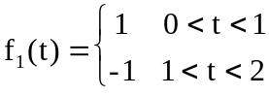

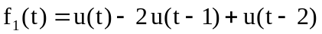

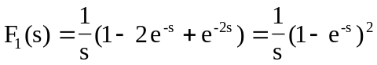

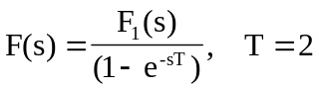
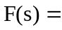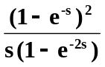

- Let

